Name: Truong Dang Truc Lam ID: B2111933 Class: CT205H - M04

# Naive Bayes

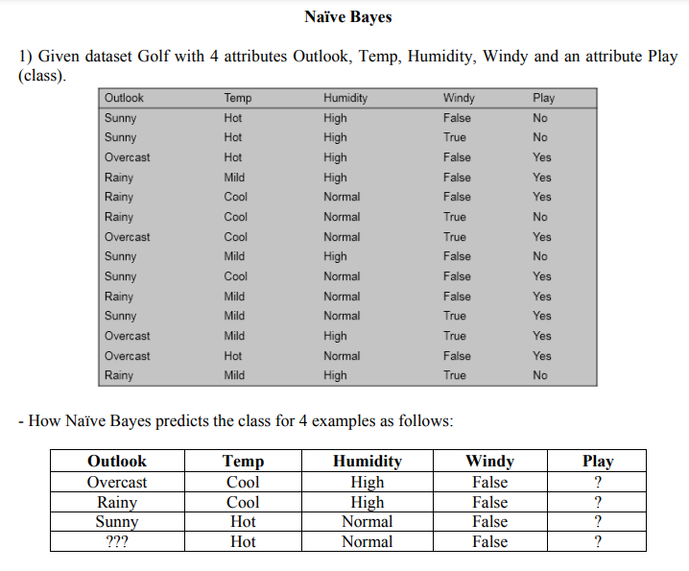

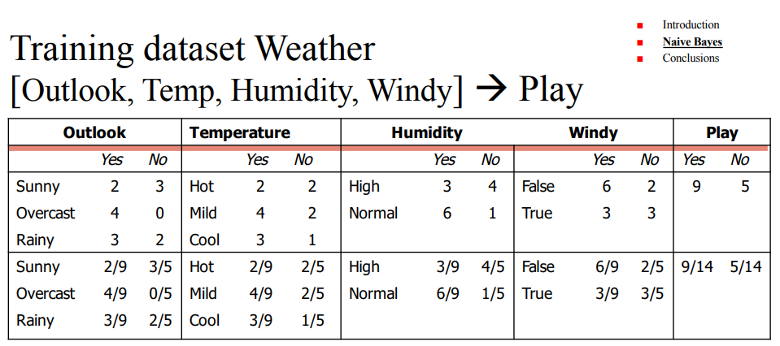

P(Play=Yes) = 4/9

P(Play=No) = 5/14

Example 1:

|  |  |  |  |  |
| --- | --- | --- | --- | --- |
| Outlook | Temp | Humidity | Windy | Play |
| Overcast | Cool | High | False | ? |

P(Play=Yes | E)

= P(Play=Yes ∣ Outlook=Overcast,Temp=Cool,Humidity=High,Windy=False)

= P(Outlook=Overcast ∣ Play=Yes) * P(Temp=Cool ∣ Play=Yes) *   
P(Humidity=High ∣ Play=Yes) * P(Windy=False ∣ Play=Yes) * P(Play=Yes) / P(E)

= 4/9 * 1/9 * 3/9 * 6/9 * 9/14

= 0.00704